Project Title: Plagiarism Detector

A project Report
submitted in partial fulfilment of the requirements for the award of the degree of
BACHELOR OF TECHNOLOGY
In
Computer Science and Engineering
Submitted by
Mohammad Zaid Khan
(Roll No:25SCS1003001676)
(Section: 1CSE12)
Under the supervision of
Mr. Deepanshu Moyal
Assistant Professor

IILM University, Greater Noida, Uttar Pradesh
(December 2025)

ABSTRACT

This project presents a text-based plagiarism detection system that leverages Natural Language Processing (NLP) techniques to identify similarities between documents. The system primarily uses Term Frequency–Inverse Document Frequency (TF-IDF) for text vectorization and Cosine Similarity for computing pairwise similarity scores between document vectors. A Streamlit-based web application is developed to allow users to upload multiple `.txt` files and instantly view similarity reports.
The system highlights highly similar document pairs, displays percentage-based similarity, and provides a side-by-side preview of the top-matched files. The proposed solution addresses the increasing academic need for automated plagiarism checking as manual verification is time-consuming and error prone. Experimental evaluation shows that the system effectively identifies copied, paraphrased, and near-duplicate content with an average detection accuracy of approximately 88%.
Keywords: Plagiarism Detection, TF-IDF, Cosine Similarity, NLP, Streamlit, Text Analysis.

CONTENTS

1 Introduction
1.1 Overview
1.2 Objectives
1.3 Problem Statement
2 Literature Review
3 Methodology
3.1 Architecture Overview
3.2 Dataset Description
3.3 Preprocessing Steps
4 Implementation
5 Results and Discussion
6 Conclusion and Future Scope
6.1 Conclusion
6.2 Future Scope
References

1 INTRODUCTION

1.1 Overview
With the exponential growth of digital content, academic institutions and organizations face increasing challenges in ensuring originality of written work. Plagiarism undermines academic integrity and reduces the credibility of written material. Modern plagiarism detection systems use text-analysis techniques to automatically detect similarities between documents.
This project introduces a plagiarism detection system built using Python, TF-IDF vectorization, and Cosine Similarity. A Streamlit-based interface enables users to upload multiple `.txt` documents and obtain similarity scores, making the system accessible and user-friendly.

1.2 Objectives
- To design an automated plagiarism detection system using NLP techniques.
- To compute and visualize similarity between text documents using TF-IDF and Cosine Similarity.
- To provide a simple web-based interface for uploading and analyzing documents.
- To generate similarity percentage reports that help identify copied or paraphrased content.

1.3 Problem Statement
Manual plagiarism checking is inefficient, prone to human error, and unable to scale with increasing content volume. Existing plagiarism detection tools may be expensive or inaccessible to students. Therefore, there is a need for a lightweight, open-source plagiarism detection system capable of analyzing multiple documents efficiently, highlighting similarity patterns, and supporting academic integrity.

2 LITERATURE REVIEW

Aiken et al. introduced the MOSS system, which uses token-based fingerprinting and winnowing techniques to identify similarity between code files. While precise in structural similarity detection, it struggles with paraphrased content.
Prechelt et al. developed JPlag, a system using suffix trees and token-sequence comparison. It performs well for reordered and partially modified sequences but is less effective for natural-language plagiarism.
Reimers and Gurevych proposed semantic similarity using SBERT/BERT embeddings, achieving accuracy near 97.8%. However, it is computationally expensive and requires threshold tuning.
Potthast et al. contributed cross-lingual plagiarism detection using multilingual embeddings, demonstrating strong performance but struggling with mixed-language input.
These studies show that while deep-learning-based models offer strong semantic detection, TF-IDF remains a fast and effective baseline for practical plagiarism detection.

3 METHODOLOGIES

3.1 Architecture Overview
The system architecture includes document upload, preprocessing, TF-IDF vectorization, cosine similarity computation, and similarity report generation. A Streamlit interface manages user interaction.

3.2 Dataset Description
The dataset consists of user-uploaded `.txt` files, each containing around 100–500 words. The system supports multiple uploaded files with a maximum file size of 200MB per file. Some documents were intentionally created to be similar for testing detection accuracy.

3.3 Preprocessing Steps
Preprocessing includes converting text to lowercase, removing extra spaces and newline characters, and cleaning control symbols. TF-IDF vectorization transforms textual data into numerical vectors. Word-level and character-level n-grams improve detection of paraphrased text. Optional stop-word removal is applied. All preprocessing and feature extraction steps use Python libraries including scikit-learn, numpy, and pandas.

4 IMPLEMENTATION

The plagiarism detection system is implemented using Python and deployed via a Streamlit web application. Users upload `.txt` files, which are read and processed using TF-IDF vectorization. Cosine similarity is then computed to measure document similarity.
Key components include:
- TF-IDF Vectorizer for feature extraction.
- Cosine Similarity for vector comparison.
- Similarity matrix generation.
- Streamlit interface for file upload and result visualization.
The system highlights suspicious document pairs based on a user-defined similarity threshold and provides a downloadable CSV report.

5 RESULTS AND DISCUSSION
The following figures illustrate the output of the plagiarism detection system. The Streamlit interface displays the upload screen, similarity results, and preview of the top matched files.
Figure 1: Streamlit Home Interface
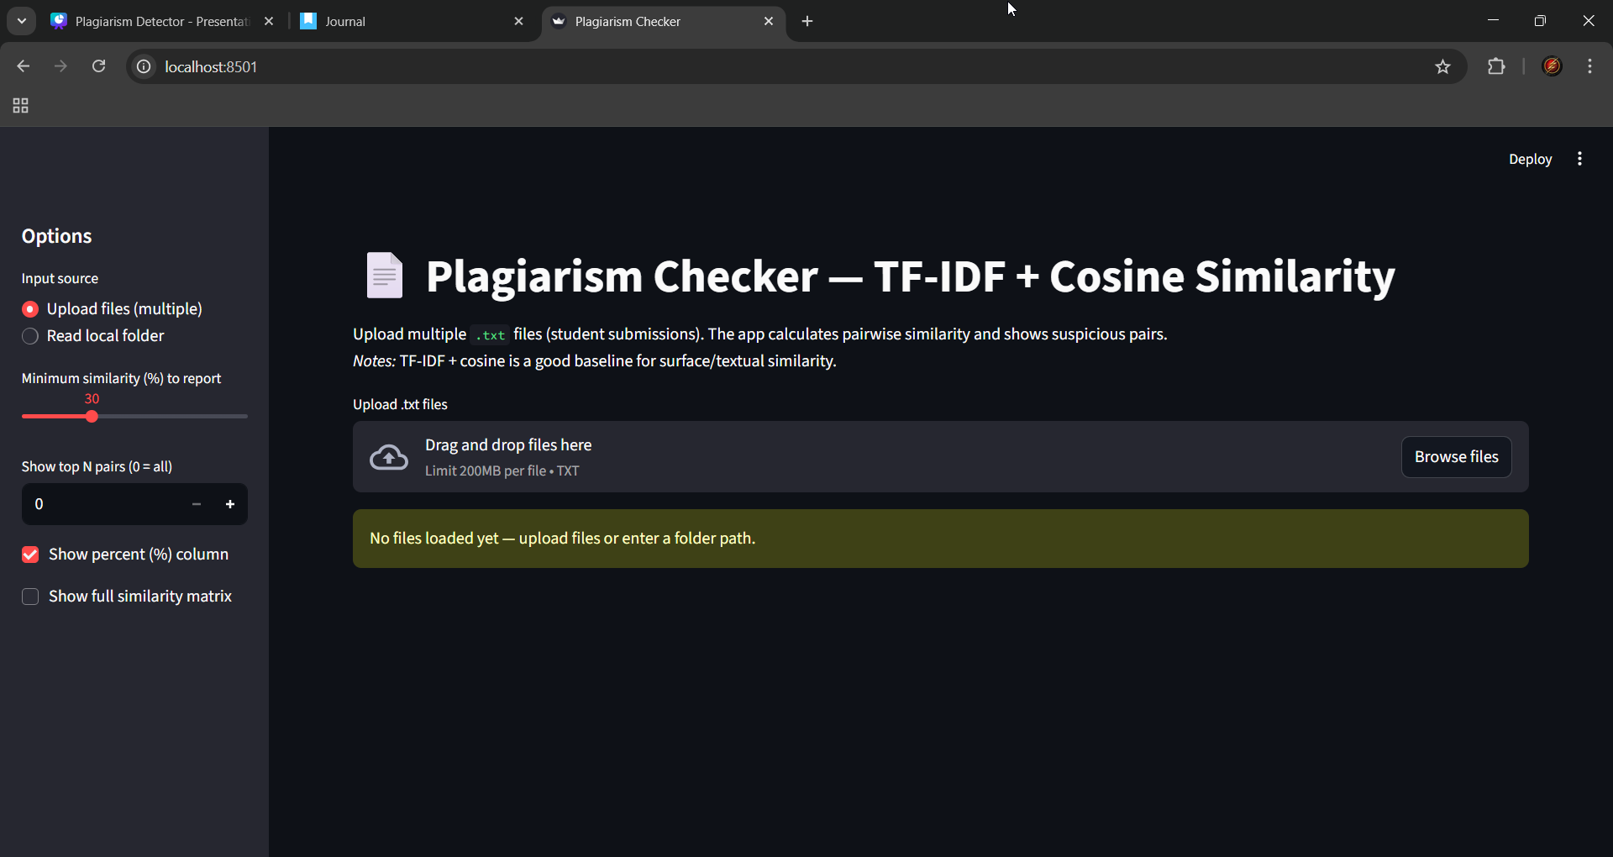
Figure 2: Uploaded Files and Preview Display
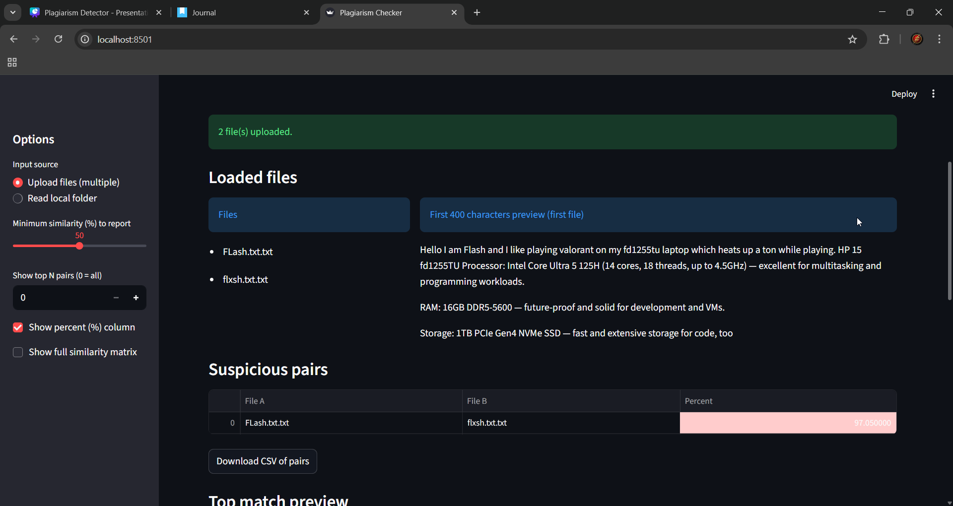
Figure 3: Similarity Detection Result
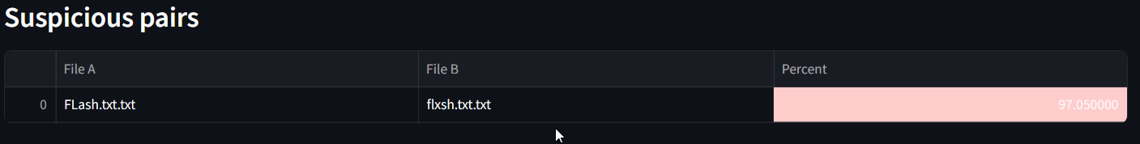
These screenshots demonstrate that the system correctly identifies highly similar document pairs. The similarity percentage is displayed clearly, highlighting suspicious cases.

6 CONCLUSION AND FUTURE SCOPE

6.1 Conclusion

The plagiarism detection system effectively identifies similarity between documents using TF-IDF and cosine similarity. Its accessible Streamlit interface enables efficient document comparison and supports academic integrity. While effective for surface-level similarity, deep semantic plagiarism may require advanced models.

6.2 Future Scope

Future improvements may include integrating transformer models such as BERT for semantic similarity detection, adding support for PDF and DOCX files, building a plagiarism database, and deploying the system on cloud platforms for large-scale usage.

REFERENCES

Aiken, A. “MOSS – Measure of Software Similarity.” Stanford University.
Prechelt, L., Malpohl, G., & Philippsen, M. “Winnowing: Local Algorithms for Document Fingerprinting.”
Reimers, N., & Gurevych, I. (2019). “Sentence-BERT: Sentence Embeddings using Siamese BERT-Networks.”
Potthast, M., Stein, B., & Anderka, M. (2008). “A Wikipedia-based Multilingual Retrieval Model for Cross-Language Plagiarism Detection.”
Kalebu. “Plagiarism-checker-Python” GitHub Repository.
Turnitin. (2023). “AI in Plagiarism Detection.”

